**Practical No:02**

# Normal -Distribution

Q1) Most graduate schools of business require applicants for admission to take the Graduate Management Admission Council’s GMAT examination. Scores on the GMAT are roughly normally distributed with a mean of 527 and a standard deviation of 112. What is the probability of an individual scoring above 500 on the GMAT?

# ii)How high must an individual score on the GMAT in order to score in the highest 5%?

**Ans:** Mean=527s.d=112 x>500

1. >pnorm(500,527,112,lower.tail=F) [1] 0.5952501
2. x>5% =

> x>0.05

>qnorm(0.05,527,112,lower.tail=F) [1] 711.2236

# Output:

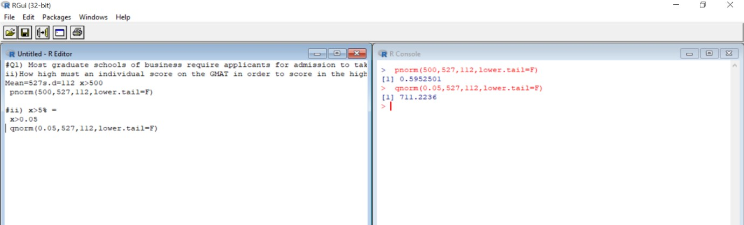

Q2) The average number of acres burned by forest and range fires in a large New Mexico county is 4,300 acres per year, with a standard deviation of 750 acres. The distribution of the number of acres burned is normal.

# What is the probability that between 2,500 and 4,200 acres will be burned in any given year?

**Ans:** Mean=average=4300 s.d=750

2500<X<4200 X<2500:

> y=pnorm(2500,4300,750)

* y

[1] 0.008197536

X<4200:

> x=pnorm(4200,4300,750)-dnorm(4200,4300,750)

* x

[1] 0.4464377 2500<X<4200:

* x-y

[1] 0.4382401

What number of burnt acres corresponds to the 38th percentile?

Ans:38th percentile=38%=0.38

X=0.38

>qnorm(0.38,4300,750) [1] 4070.889

# Output:

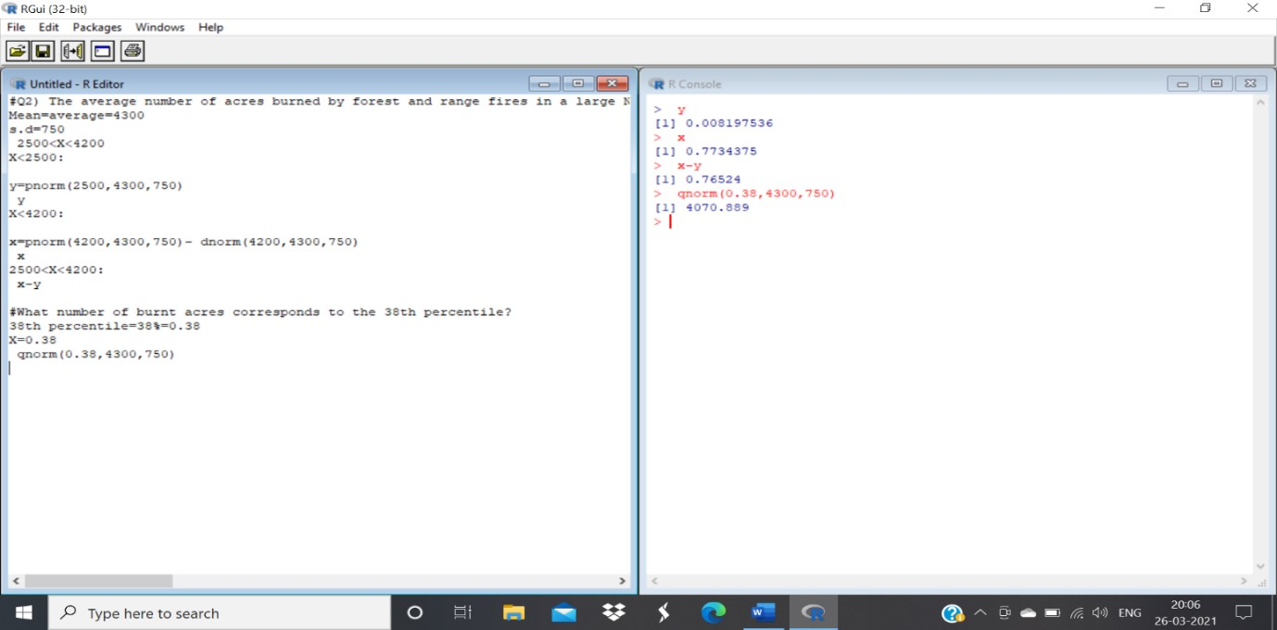

Q3) The Edwards’s Theatre chain has studied its movie customers to determine how much money they spend on concessions. The study revealed that the spending distribution is approximately normally distributed with a mean of $4.11 and a standard deviation of $1.37. What percentage of customers will spend less than $3.00 on concessions?

# What spending amount corresponds to the top 87th percentile?

**Ans:** Mean=40.11 s.d=1.37

1. X<3

>pnorm(3,4.11,1.37) [1] 0.2089072

1. X=87th percentile=0.87

>qnorm(0.87,4.11,1.37,lower.tail=F) [1] 2.566844

# Output:

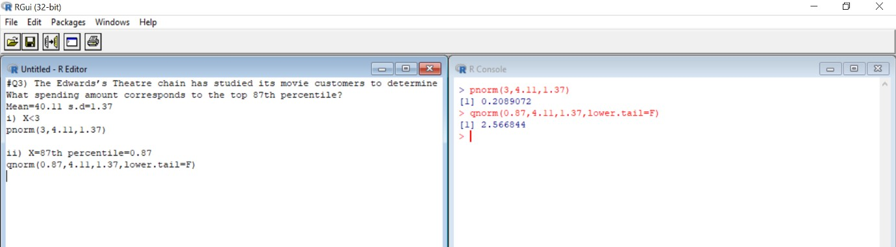

Q4) X is a normally distributed variable with mean μ = 30 and standard deviation σ = 4.

# Find

a) P(x < 40)

# b) P(x > 21)

c) P(30 < x < 35)

**Ans:** a) pnorm(40,30,4)-dnorm(40,30,4) [1] 0.9894083

b) pnorm(21,30,4,lower.tail=F) [1] 0.9877755

c) pnorm(35,30,4)-dnorm(35,30,4)-pnorm(30,30,4) [1] 0.348688

# Output:

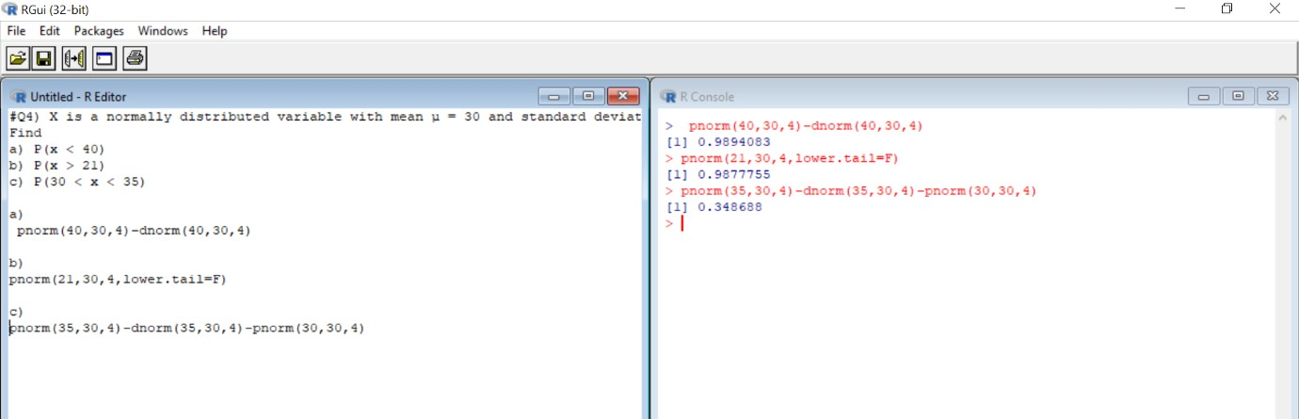

Q5) A radar unit is used to measure speeds of cars on a motorway. The speeds are normally distributed with a mean of 90 km/hr and a standard deviation of 10 km/hr. What is the probability that a car picked at random is travelling at more than 100 km/hr?

**Ans:** Mean=90 s.d=10 X>100

>pnorm(100,90,10,lower.tail=F) [1] 0.1586553

# Output:

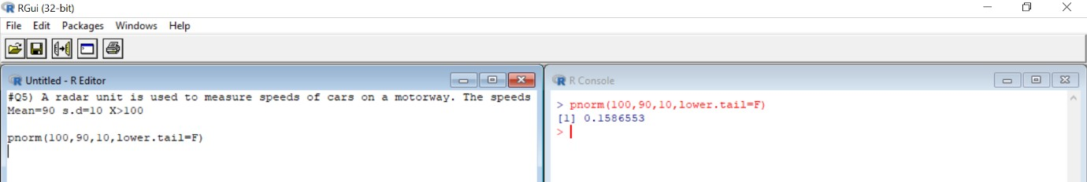

Q6) For a certain type of computers, the length of time between charges of the battery is normally distributed with a mean of 50 hours and a standard deviation of 15 hours. John owns one of these computers and wants to know the probability that the length of time will be between 50 and 70 hours ?

**Ans:** Mean=50 s.d=15 50<X<70

>pnorm(70,50,15)-dnorm(70,50,15)-pnorm(50,50,15) [1] 0.3978548

# Output:

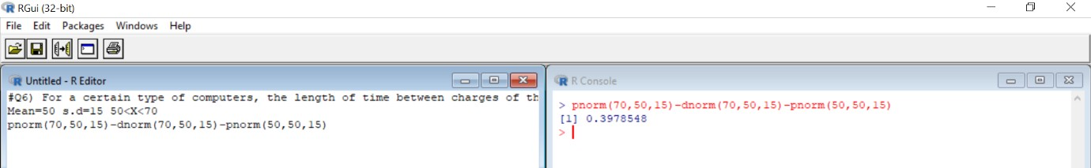

Q7) Generate 10 random numbers from normal distribution with mean=12 and standard deviation=4

# Find mean of sample. Find standard deviation of sample. Ans: Mean=12

s.d=4

* a=rnorm(10,12,4)
* a

[1] 9.272671 10.159778 8.067723 13.981327 14.903270 14.669195 15.819146

[8] 5.298671 7.179258 4.146990

* mean(a) [1] 10.3498

>sd(a)

[1] 4.254909

# Output:

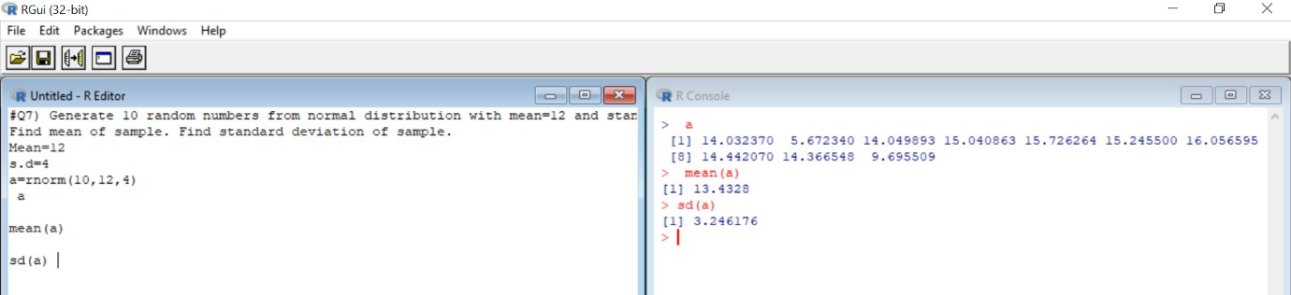

Q8) Evaluate the probability for

**Ans:** Mean=50variance=100 =>s.d=√variance = 10 a) >pnorm(70,50,10)

[1] 0.9772499

b) >pnorm(65,50,10,lower.tail=F) [1] 0.0668072

c) >pnorm(30,50,10) [1] 0.02275013

d) >pnorm(60,50,10)-dnorm(60,50,10)-pnorm(35,50,10) [1] 0.7503405

e) >qnorm(0.4,50,10) [1] 47.46653

# Output:

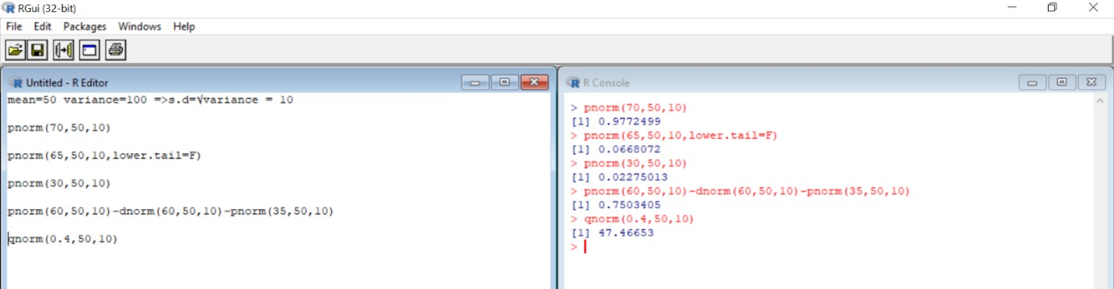

Q9) Generate 100 random numbers and evaluate its mean, median and variance.

**Ans:** > x=rnorm(100)

* x

[1] 1.232222210 1.500724335 2.090438380 -0.149592228 -3.346933833

[6] 0.401185921 0.573559239 -2.086953499 0.123957777 0.067068317

|  |  |  |  |
| --- | --- | --- | --- |
| [11] | 0.021964374 | 0.770019513 -1.266550206 | -0.660191227 0.330483566 |
| [16] | 1.082429774 | 0.144791408 -0.943401653 | 0.010352382 2.285993849 |
| [21] | 0.343372245 | -1.319544951 -0.783149297 | -1.139114121 -0.120975906 |
| [26] | 1.195447083 | 0.393645794 1.148945788 | 1.204047652 0.341601738 |
| [31] | -0.578237071 | 1.615074630 0.088088444 | 0.017289279 -0.455454435 |
| [36] | -0.254001133 | 0.195612798 -1.936312460 | 1.623942865 -1.850870135 |
| [41] -0.245507817 -0.657558454 2.602248609 | | | 0.267342393 -1.033037633 |
| [46] -0.554263489 0.282647990 -1.325653437 | | | 0.239224815 0.244266004 |

|  |  |
| --- | --- |
| [51] 1.821649582 1.446218738 -0.904503376 | 0.581344577 0.371543696 |
| [56] -0.825714637 0.221470758 1.125328757 | 0.481534054 -0.352004143 |
| [61] -1.758681027 -2.264325688 2.824811142 | 0.930739940 1.573833854 |

[66] 0.403954243 0.064935726 0.451119150 -0.651334164 1.901316242

[71] -0.524882078 -1.169000712 0.791408984 -0.589027622 -0.089571003

[76] 0.223716888 0.617878030 2.517468604 -0.300281266 -1.058761752

[81] -0.776891551 -0.579105018 0.061670553 -0.446324860 0.779235151

[86] 0.769324163 -0.008693308 -0.664543679 -0.533860719 0.932028646

[91] 1.437132916 0.077423599 -0.393383943 0.930456492 1.612780258

[96] -0.390976581 0.986148480 2.084471886 1.195879564 0.908026864

* y=pnorm(x,mean(x),sd(x))
* y

[1] 0.8272644930 0.8816300823 0.9563459946 0.3857133753 0.0008286165

[6] 0.5797756242 0.6387965226 0.0216649629 0.4815606532 0.4613482399

[11] 0.4453912387 0.7021786984 0.0988869566 0.2276950916 0.5549526526

[16] 0.7909293737 0.4889773354 0.1588107517 0.4412963449 0.9702443823

[21] 0.5594968197 0.0908985027 0.1959278357 0.1201728727 0.3955218255

[26] 0.8187393556 0.5771416224 0.8075892968 0.8207563604 0.5588730417

[31] 0.2503857434 0.9006538811 0.4688077084 0.4437418707 0.2865012506

[36] 0.3505843854 0.5070803607 0.0296476345 0.9020299899 0.0351711466

[41] 0.3533993673 0.2284055633 0.9848750845 0.5325975908 0.1402047557

[46] 0.2572429513 0.5380286954 0.0900093994 0.5226051291 0.5243979022

[51] 0.9291854921 0.8717081954 0.1673669476 0.6413971695 0.5694012003

[56] 0.1855896494 0.5162879400 0.8017692410 0.6075995356 0.3187285996

[61] 0.0420498967 0.0146694072 0.9909982323 0.7499065293 0.8940685943

[66] 0.5807417961 0.4605921566 0.5971234324 0.2300901734 0.9383284240

[71] 0.2657781959 0.1149122838 0.7087639012 0.2473312227 0.4063625433

[76] 0.5170874097 0.6535118282 0.9817403411 0.3353928155 0.1351502624

[81] 0.1974766348 0.2501393131 0.4594348076 0.2892822881 0.7050242544

[86] 0.7019634849 0.4345937709 0.2265232860 0.2631547649 0.7502721497

[91] 0.8699996859 0.4650215120 0.3056537517 0.7498260737 0.9002955670

[96] 0.3064078737 0.7653669993 0.9558509403 0.8188411192 0.7434162424

* mean(x)

[1] 0.1757367

* median(x) [1] 0.1702021

>var(x)

[1] 1.254081

# Output:

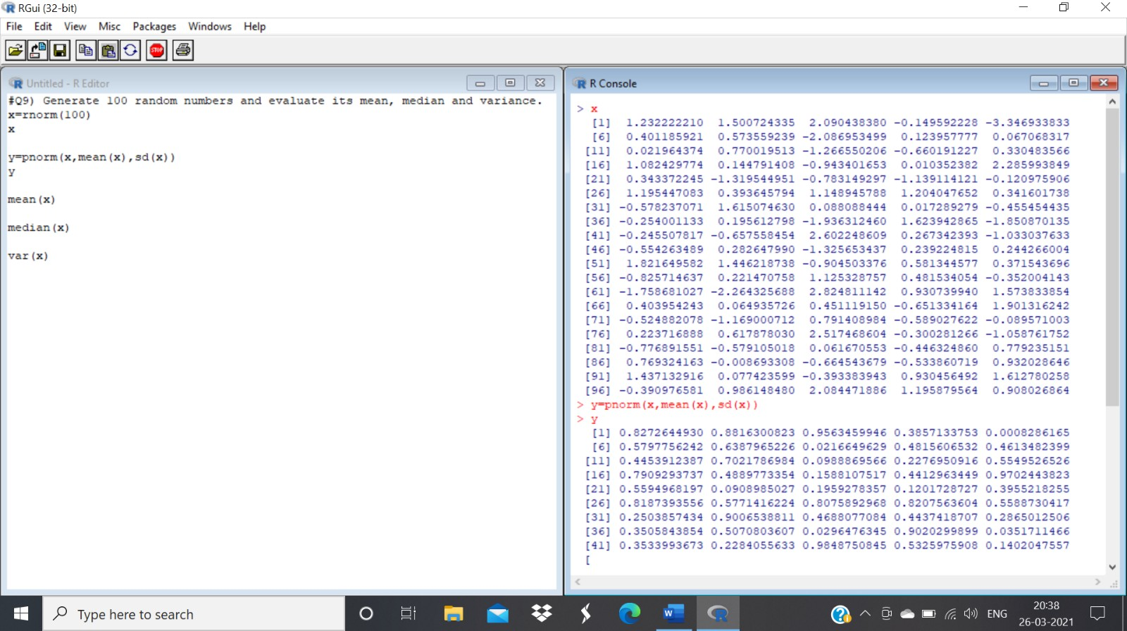

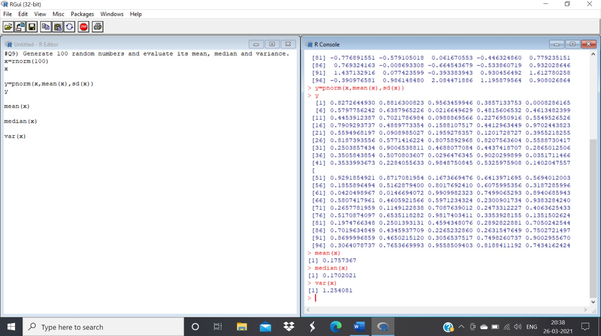

Q10) Plot a Standard normal distribution curve by taking a sequence starting from -4 and end at 4 with difference 0.1

# Also plot cumulative distribution function for the same with proper labels.

# Ans: > x=seq(-4,4,0.1)

* x

[1] -4.0 -3.9 -3.8 -3.7 -3.6 -3.5 -3.4 -3.3 -3.2 -3.1 -3.0 2.9 -2.8 -2.7 -2.6 [16] -2.5

-2.4 -2.3 -2.2 -2.1 -2.0 -1.9 -1.8 -1.7 -1.6 -1.5 1.4 -1.3 -1.2 -1.1[31] -1.0 -0.9 -

0.8 -0.7 -0.6 -0.5 -0.4 -0.3 -0.2 -0.1 0.0 0.1 0.2 0.3 0.4 [46] 0.5 0.6 0.7 0.8 0.9

1.0 1.1 1.2 1.3 1.4 1.5 1.6 1.7 1.8 1.9 [61] 2.0 2.1 2.2 2.3 2.4 2.5 2.6 2.7 2.8 2.9

3.0 3.1 3.2 3.3 3.4 [76] 3.5 3.6 3.7 3.8 3.9 4.0

* y=pnorm(x,mean(x),sd(x))
* y

[1] 0.04454623 0.04868907 0.05313431 0.05789540 0.06298558

0.06841778 [7] 0.07420453 0.08035782 0.08688907 0.09380899 0.10112747

0.10885350

[13] 0.11699506 0.12555900 0.13455099 0.14397537 0.15383513 0.16413174

[19] 0.17486516 0.18603373 0.19763411 0.20966126 0.22210837 0.23496685

[25] 0.24822633 0.26187463 0.27589781 0.29028015 0.30500423 0.32005098

[31] 0.33539970 0.35102820 0.36691286 0.38302874 0.39934970 0.41584852

[37] 0.43249702 0.44926627 0.46612663 0.48304802 0.50000000 0.51695198

[43] 0.53387337 0.55073373 0.56750298 0.58415148 0.60065030 0.61697126

[49] 0.63308714 0.64897180 0.66460030 0.67994902 0.69499577 0.70971985

[55] 0.72410219 0.73812537 0.75177367 0.76503315 0.77789163 0.79033874

[61] 0.80236589 0.81396627 0.82513484 0.83586826 0.84616487 0.85602463

[67] 0.86544901 0.87444100 0.88300494 0.89114650 0.89887253 0.90619101

[73] 0.91311093 0.91964218 0.92579547 0.93158222 0.93701442 0.94210460

[79] 0.94686569 0.95131093 0.95545377

* plot(x,y,main="Plot of CDF",ylab="density")

# Output: